GIT COMMANDS

Command: git init -> initializes the new git repository which is empty.

**ls -a**

shows the hidden files.

**ls -al**

to show the hidden files in long format.

Under the. git folder all the information regarding the git folder would be there.

There are three stages in git:

1. Untracked
2. Staged
3. Commit

Moving back to the untracked to staged, we need to use the following command:

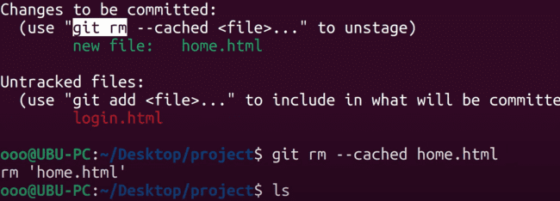

git commit without giving “-m”, then editor would be open and then we need to provide the comment to save the file.

Adding the committing at the same time:

**git commit -am “<COMMENT>”**

GIT CONFIG: Following are the commands to config the name and the email address for the github.

Configuring the email and the name of the user and checking that, user and the email address is configured as:

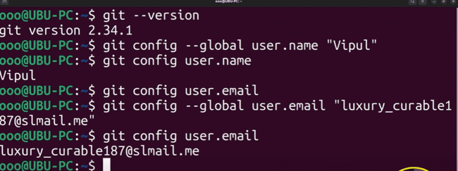

**GIT CHECKOUT:**

The command touch is used to create the file as shown below:

To create a new branch, we need to use the command “git branch <BRNACH_NAME>” and to view the branches we need to use the command as “git branch” as shown below:

To switch to the feature branch, we need to use the “git switch <BRANCH_NAME>” and to go back to the previous branch, we need to use the command “git switch -”:

Command “git switch -c test” would switch the branch to test branch and create the test branch.

Also “git checkout -b anotherBranch” would switch the branch to anotherBranch and create that branch.

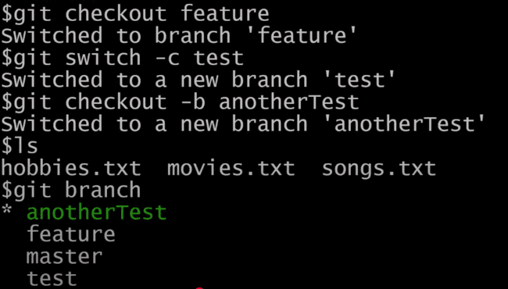

If you want to discard the changes, you need to use the command “git checkout <FILE_NAME>” and that changes would be discarded and cannot be undo as well as shown below:

Like in the following example, there is one untracked file hobbies.txt and checkout that file would clear that. The files which are not in staging that would be discarded using the checkout command.

In the following two files are there, one is untracked, and one is in staging.

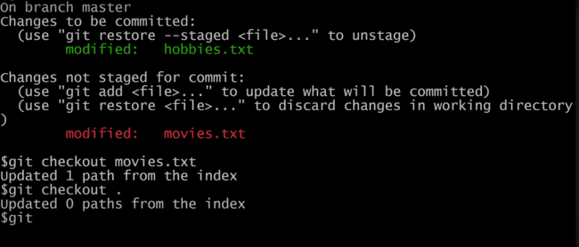

Command “git checkout” would discard the untacked file only, but staging file would be there.

Command “git –oneline” is used to check the HEAD version of the branch in which it currently is.

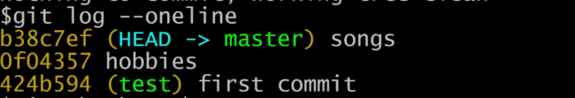

DETACHED HEAD:

In this case head is pointing to the commit, instead of pointing to any of the branch or any other commit. Pointing the head to some commit as shown below using the ref name:

For the detached head, we can check that it is pointing to some commit:

Cat HEAD is pointing to some reference, not to a folder as shown.

But if we are in the branch, head would be pointing to some branch.

HEAD 🡪 BRANCH 🡪 pointing to latest commit.

But in the below case, head to pointing to commit as shown:

HEAD 🡪 LATEST COMMIT

And “git branch” would do the following:

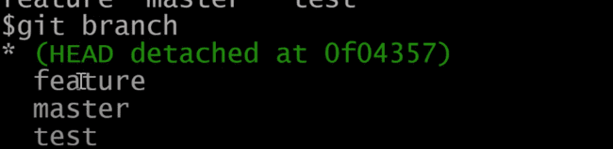

And switching to master:

If you want to switch to the HEAD to the previous heads, then we need to use the wildcard “~”:

Command “git checkout HEAD~2”:

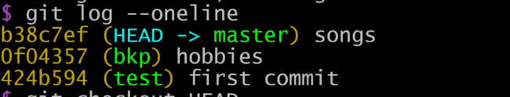

After “git checkout HEAD~2”:

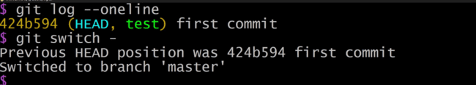

There is one UI available for the GIT which is GitKraken Client as:

Importing the project to the GitKraken Client:

Now if execute “git checkout HEAD~1”, then UI would look like this:

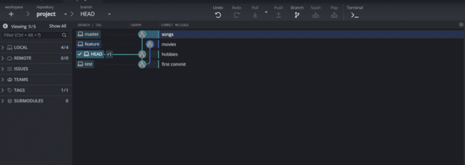

After “git status -”, that has been switched to the same branch.

Command “git log” displayed the messages and committed changes:

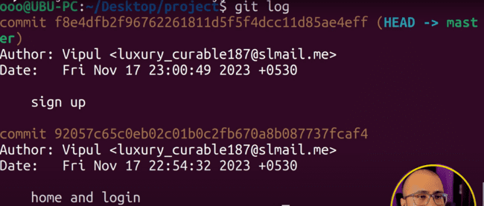

After changing in one file, if we need to add the same file to the “sign up” commit, we need to use the amend command.

git commit –amend -m“sign up..” as shown below:

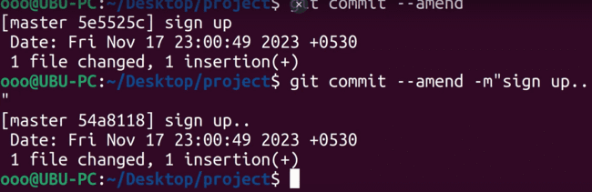

“git log” will display the updated commit message as shown below:

“git log --oneLine” would display the one line message for the commit as shown below:

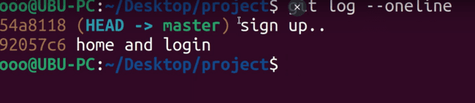

“.gitignore” If we place any code in this file, that files or folders would be ignored. For example: we have added the following files and also added the following code in the “.gitignore” file as:

These are the files:

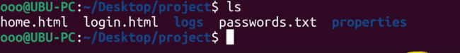

“cat .gitignore” contains the following code:

“git status” would be clean when code is added in the “.gitignore” file.

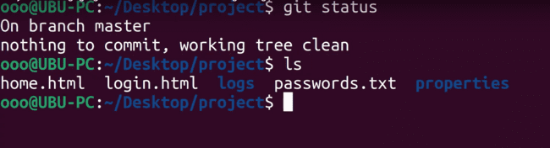

BRANCHES in GIT:

We have fetched the branches from the base code and for one branch we have added the “about.html” file and for another branch, we have added the “logout.html” file, and we can test them differently and then merge the same in the base branch.

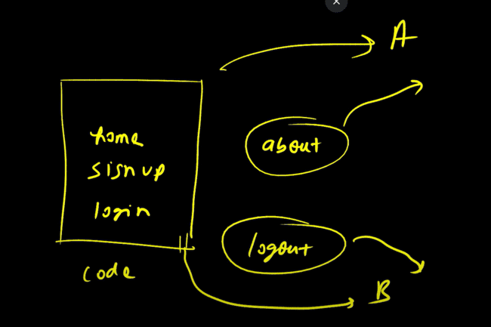

HEAD always points to the latest branch in the master when we do the commit, it moves to above again to the latest branch.

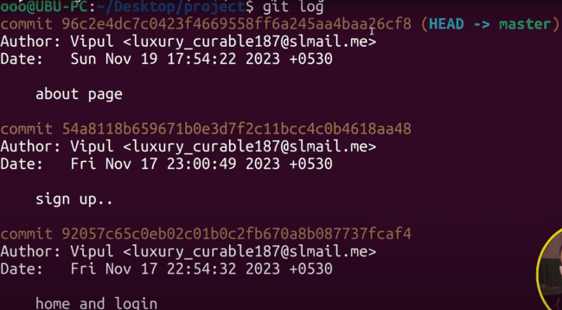

Merge the branches to the main master branch:

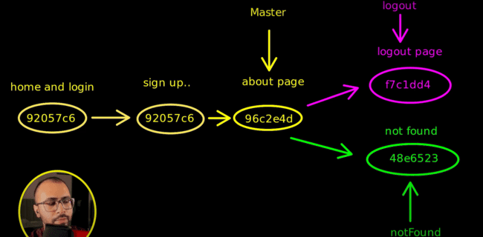

Now if we want to merge the logout code to the master, we can do that also, switching to the master and then merge the “logout” branch:

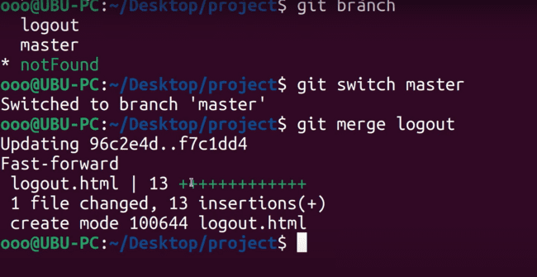

To delete the branch, we need to use the following command:

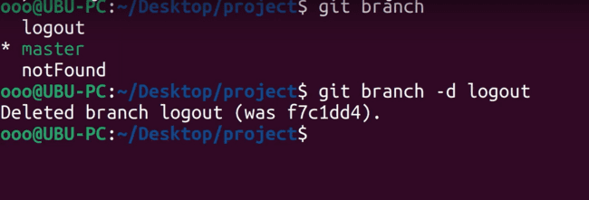

If the branch is not merged, then we are unable to delete that, and if we still want to delete that, we can do that using the “-D” which is force delete.

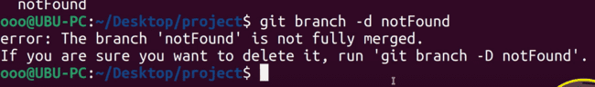

Now if we have done the changes in both the branches on the same line of the html page, then there would be the conflict. So, issue would be there.

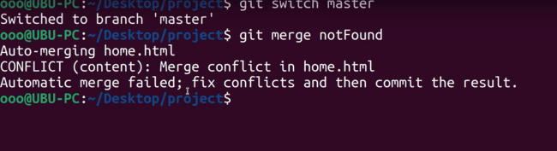

If you open the home.html page, then we’ll be seeing the following message on the screen for the master branch and then after that for the other branch.

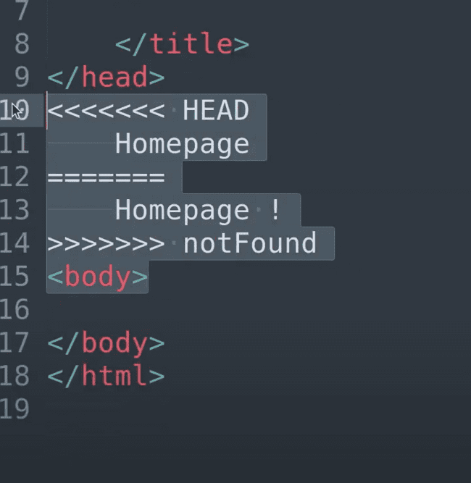

After resolving the conflicts, we can use the following to merge:

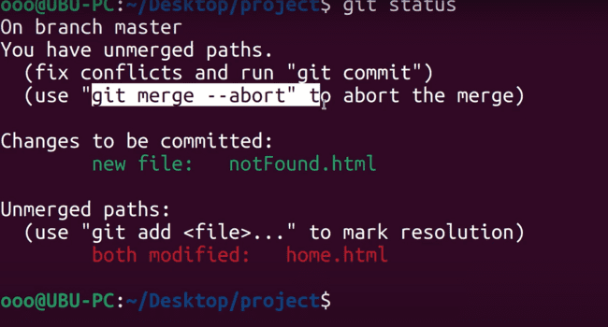

Other approach:

If we create the branch from master and add a page to that branch and then again from master, we add another branch and add a new html page, then a new merge would be created as:

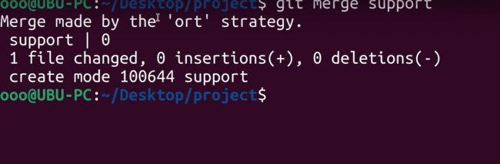

Previously, it was fast forward one, now it is ‘ort’ strategy. What happens is, a new commit is created for the same as:

Need of HEAD:

It makes the branch switching easier, as head points to the reference of the current branch and contains the hash information which has been shown below:

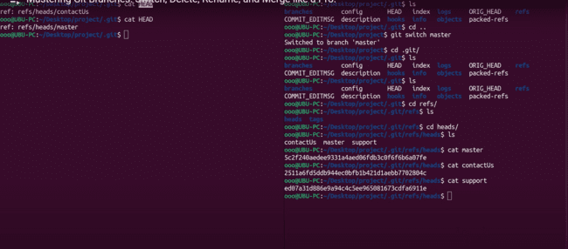

To check the difference between the files, we can use the “diff” command as:

“git diff” which shows the difference between all the files.

“git diff <FILE_NAME>” which shows the difference for the specific file

“git diff --staged” shows the difference between the files that are in staging.

We can also check the difference between two commits as well:

“git diff <OLD_ONE>..<NEW_ONE>”

“git diff 9288..9000”

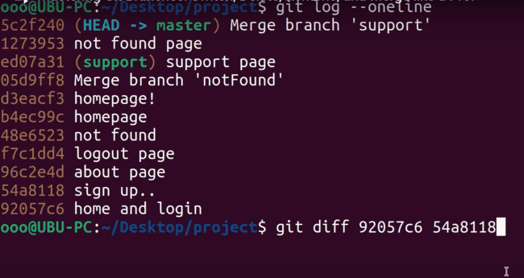

To check the difference for every files even that would be untracked or that would be staged, then we need to use the following command, which will compare to the last commit:

STASH:

Example: if we change the branch and we want that local changes would remain to the previous branch and would be saved and after that when we come back, we can get those changes, that can be done using the stash command.

Changed in the home.html and that is untacked

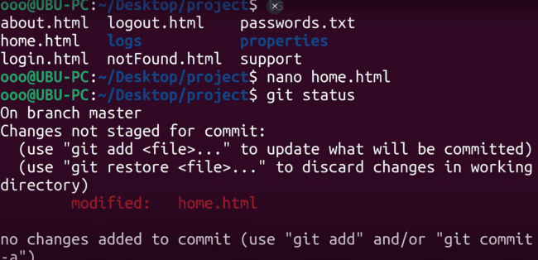

Now, if you want to switch to another branch and want the changes would not be there in the other branch then:

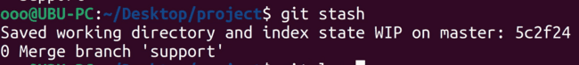

“git stash” would put the files in the main memory and working tree would be clean.

And saved in the last commit:

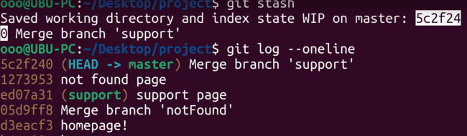

Stash the changes, switching the branch and then come back to the same branch.

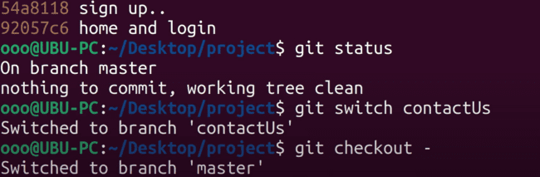

“git stash list” to list the stash changes:

To get back the stash changes: “git stash pop”

After this if we run the command “git stash list”, then that would be empty.

If you want that list won’t be empty, then you need to use, then add a new file and stash again:

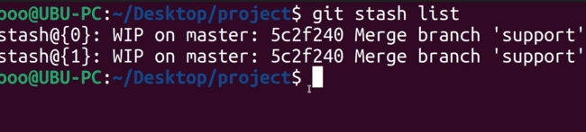

In this scenario, if you want a particular change, which would either be the first one or the last one, then you need to use the following:

“git stash apply” will pick the last change and execute the pop command on that as well.

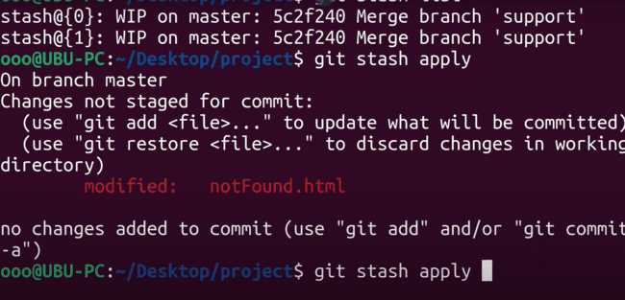

To delete something from the stash list, then you need to do the following:

Also “git stash clear” would clear the whole stash list.

If you want to stash a particular file, then you need to use the following command:

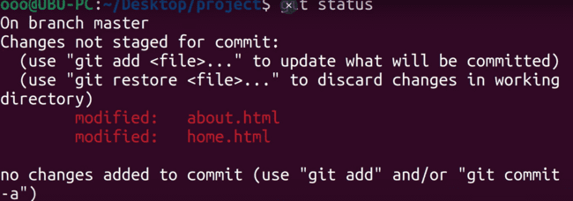

We can also use the message while stashing the git changes.

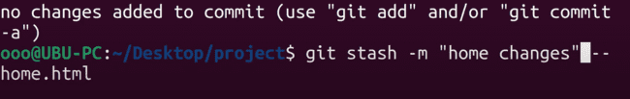

Command to show the changes:

**To see the exact changes, we need to use “git stash show -p stash@{0}”.**

Home.html in staged and about.html is untracked:

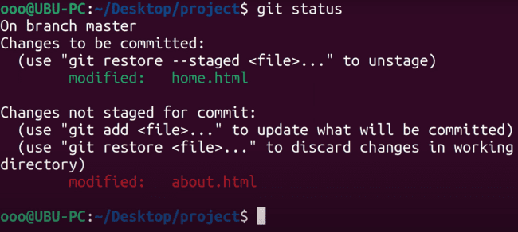

There is one more concept, if we have just created a new file, then it would be untracked, like that file is not used in the staged or even tracked and newly created.

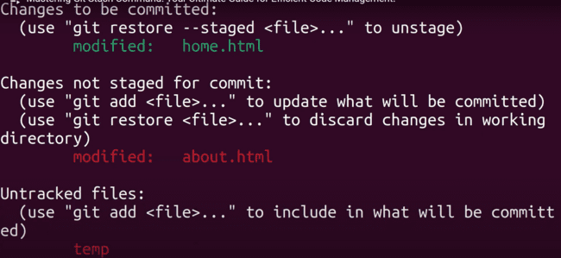

Doing git stash and then git status, temp file would also be there as well.

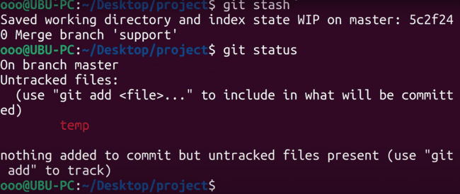

*Untracked file is not stashed, to make this file as stash we need to use the following command:*

First, you need to provide the command “git stash pop” and after that following command needs to be executed:

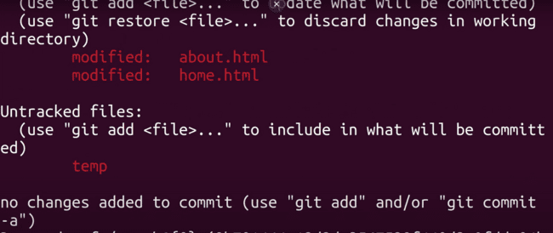

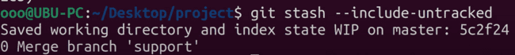

That temp untracked file would also be included, and we can see that using the “git status” command.

**GIT RESTORE**

Two files are there:

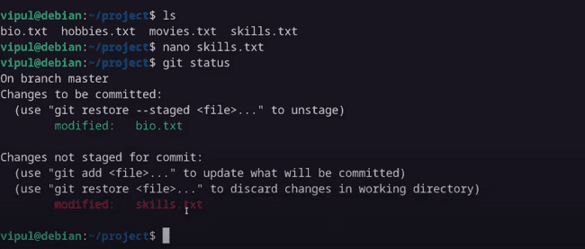

To make the file unstaged, you need to use the “restore” command:

Using the command “git status” we can see that file is in unstaged:

To discard from the unstaged, following command needs to be used:

That file would be gone now:

To remove both the files, we need to use the following command “git restore –staged --worktree”:

“git restore .” also do the same:

If we want to check the files of the branch “skills”, what is the content of the file movies.txt, without changing the HEAD, then following command needs to be executed:

Which is empty:

“git restore .” will come back to the master again. And, we can see the contents of the file movies.txt.

To check all the files on that source, we need to use the “git restore –source=244hv .”

To go to the “first commit” source, we need to use:

If we commit the files using some source, then we can use the following:

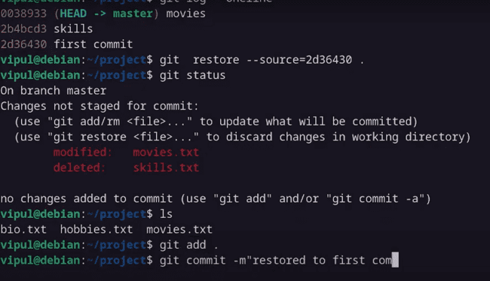

A new commit would be created as well:

To go to the HEAD, then we need to use the following as HEAD in source, otherwise, need to use, HEAD~1, or HEAD~2:

GIT RESET: is also known as UNDO -> moving head to the specific state.

With the GIT RESTORE, we can check the photo of previous commit and also moves the files to the specific commit and can make a new commit as well, but if you want to delete the commit history for a particular branch, then we need to use the GIT RESET.

You have added the file to staged and want to get that back to the unstaged one, then we can use the following:

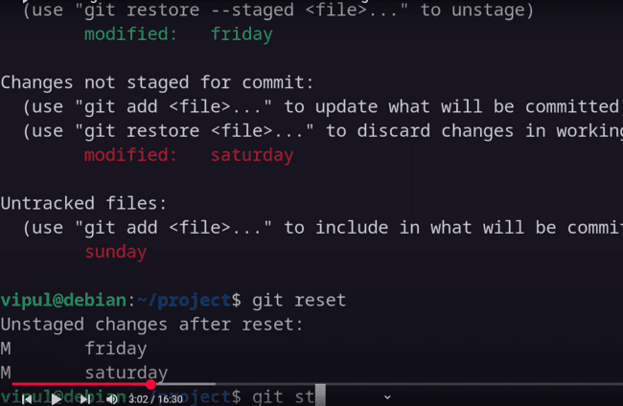

After reset, the files would be:

Second use of the RESET:

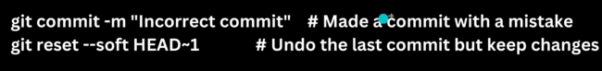

HEAD~1 -> goes back to the previous commit to HEAD.

--soft or –hard can be used in the command.

OTHER:

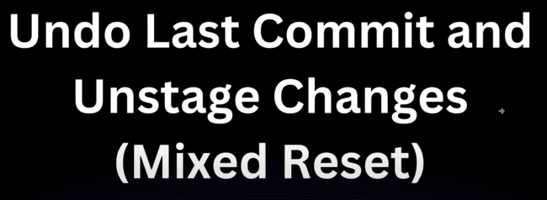

--soft sends out the changes in the staging area and undo the commit.

But –mixed, undo the commit and also sends out the changes in the unstaged area.

--hard discards the changes and undo the last commit.

Example:

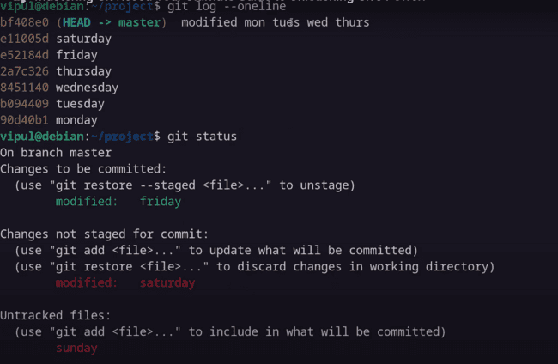

--hard goes to previous commit and all other commits are deleted and files as well instead of untracked files only

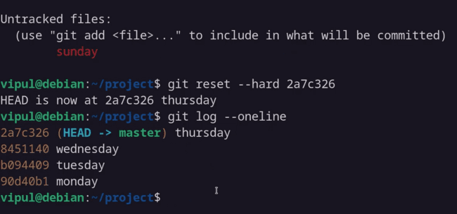

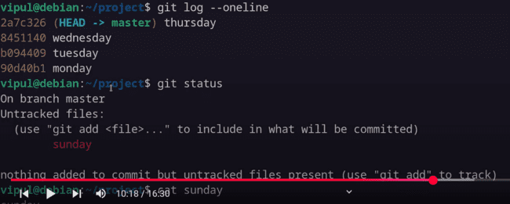

Again we have added the same files to check the other restore command.

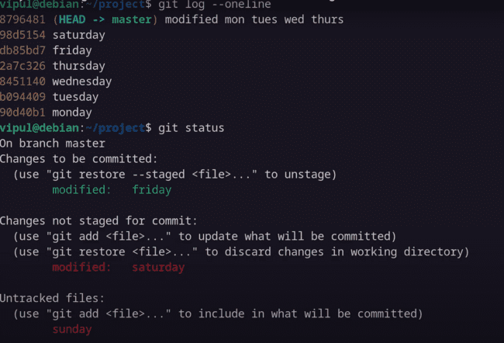

--soft will move all the staged changes from that commit to the previous commit and move the head to that previous commit, unlike –hard, which would discard all edits.

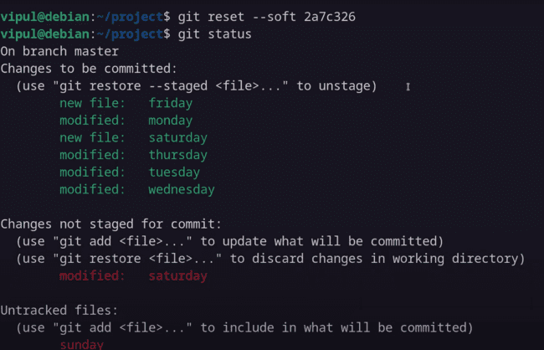

For –mixed, we don’t need to specify the mixed in the command and HEAD is reset to the previous commit and changes has been moved to the unstaged files and unstaged and staged would move to the the untrack one.

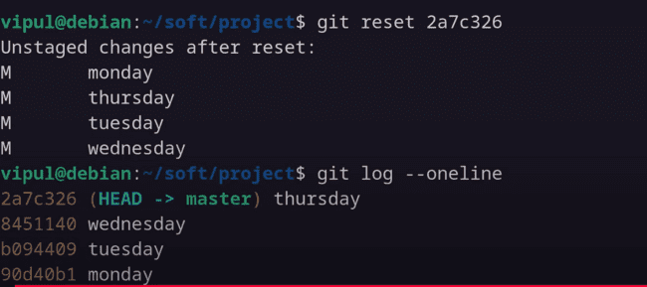

GIT REVERT: not changing the commit history and want to undo the changes, then revert need to use which would create a new commit.

*Now if someone is working in the master branch and we delete that using reset and move to the other branch “games”, then it would create issues while merging the code which would create the conflict.*

*So we can use ‘git revert’*

Which branch we need to undo, for that hashcode we need to give in the revert.

This command did not delete the history, but added a new commit as:

CREATING SHORTCUT FOR THE GIT COMMANDS:  
Like for ‘git status’ we can use the ‘git st’ using alias.

Go to the home directory and need to open the .gitconfig file.

* nano .gitconfig

And save the file.

Now ‘git st’ gives the same output as ‘git status’:

For commit:

Adding the alias using the command line: adding checkout

To write “git status” as ‘gst’, then you need to do the following:

Opening the file .bashrc, and at the end add the command:

To restart the script, use the following command:

* source .bashrc

GIT REBASE: